**Pooch**

**User Manual**

**Code Release 1.0**

**Oct 30, 2019**

**Introduction**

Welcome to Pooch! The dog-focused petcare web app with plans to become an all-in-one service for everything pet-related. Our users are dog owners, people who want to adopt dogs, and dog service providers. You can view our first version [here](https://cecs-491-1934c.web.app/).

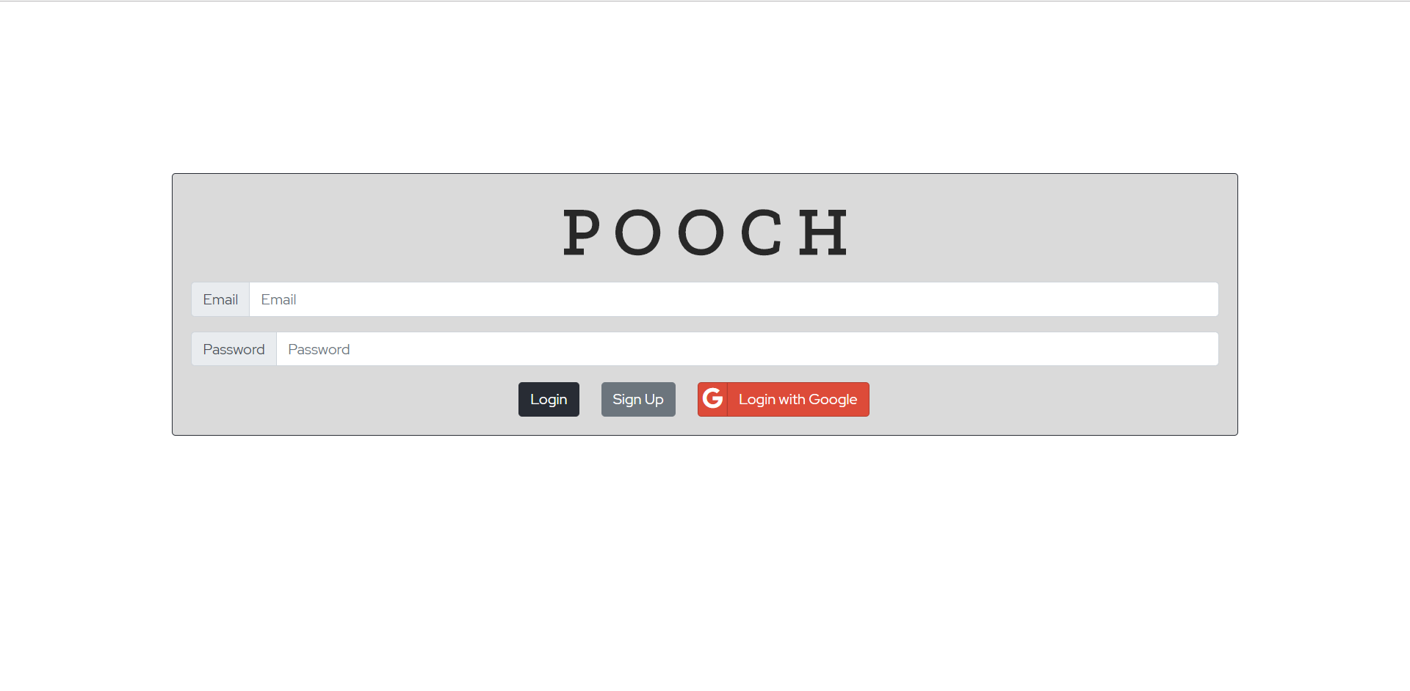

**New Users**

1. The website is hosted online using Firebase.
2. The way users can access our web application is through the link provided on the board and in the previous slides.
3. The ways to sign in as a NEW USER for our application is either:
   1. Sign up directly as a new user.
      1. Type in your valid email address and a suitable password to enjoy the features.
   2. Sign in using the Google API (an additional feature our application provides)
4. Either way, the user signs in, it takes the user to the owner profile page.

**Logging In**

1. Existing users type in the correct URL.
2. The ways to log in as a registered USER for our application is either:
   1. Log in directly -
      1. Type in your registered email address and the correct password to enjoy the features.
   2. Log in using the Google API, if your account is validated and identified by Google service.
3. Either way, the user logs in, it takes the user to the owner profile page.

**Navigation**

The pages of the web app are visible in the navigation bar located at the top of the page.

**Home Page**

This page is visible when the user logs in and can also be viewed by clicking POOCH in the navigation bar. It is the face of the website and will be feature-rich, displaying almost everything a user needs in a glance. Currently, the user can enter their name, age, whether to display their age publicly and a bio. The “Update Profile” button does not currently change what is displayed to the user. The right side of the page is left blank for a news feed to be added later. The profile picture shown at the top of the page will be customizable in the future.

**Your Pets**

This will allow users to view and alter details about their pets. The user can add their pet’s name, gender, breed, color, and date of birth. The “Submit” button adds this information to a table. When they return to this page, all of their pets can be easily viewed alongside one another. In the future, users will be able to add pictures of their pets and choose one image to be an icon alongside their pet’s information in the table.

**Dog Walking**

Users can view dog walkers who have signed up through the form on the same page. In the future, the form to become a dog walker with Pooch will be on a separate page. Dog walkers will have to upload key documents to verify their identity. Users will be able to view the profiles of individual walkers. Dog walkers will also have a rating based on the reviews left for them.

**Dog Boarding**

Users can view dog boarding companies who have signed up through the form on the same page. In the future, the form to become a dog boarder with Pooch will be on a separate page. Dog boarders will have to upload key documents to verify their identity and address. Users will be able to view the profiles of individual dog boarders. Dog boarders will also have a rating based on reviews left for them.

**Dog Services**

In the future, users will be able to view nearby pet supply stores, pet grooming services, adoption centers, and vets.

**Dog Meetup**

Users can schedule meetups at parks to let other dog owners know their pets will be looking for friends to play with. Users can also view meetups scheduled by other users. In the future, only meetups nearby will be displayed. Clicking on the meetup in the table will allow users to see additional information such as pictures.

**Dog Records**

In the future, users will be able to upload PDFs of their pet’s medical records to the website. Users will be able to access these files from anywhere, including on their phone while at the vet. This would be useful if a user forgets to bring an important document into the vet or if they have to take their pet into a new vet in a different city and don’t have their pet’s medical records easily accessible.

**Logout**

Users can log out by clicking the “Logout” button on the right-hand side of the navigation bar.